Table 1: Oral Reading Fluency Assessment [Please attach the oral reading probes with the recorded miscues on the examiner’s copy]

Examiner’s Name __Jen Mathieson____ Date of Administration 9-15-16, 9-21-16, 9-27-16_
Student’s Initials ___MK____ Name of ORF Assessment : Fountas & Pinnell, Running Record, MAZE, QRI
Grade Level ____5______

Table 1. Cover Page and Individual Summary for Oral Reading Fluency Assessment & Results
(report results of probes for each text and level read by student).

1.1 Enter the assessment information into this table. [Note. You may adapt this table according to your purposes to report performance across passages on the Oral Reading Fluency assessment.] Add rows as needed.]
Text/Level | wcpm | errors per minute | Fluency  %ile/Grade  Comparison | Accuracy % | Acc Level (indep, inst, etc.) | Comprehension % of story parts recalled of % comprehension | Comp Level (indep, inst, etc) | General Comments (observational notes or information) | Overall Summary of performance at this level (indep, inst, frustration)
Fishing Smarts/ R | 95 |  | 43% 5th grade, 2 score | 98 | Instructional | 8/10 | Instructional | This student struggled with new words and repeated many words. | I feel this is the student’s instructional level. He was able to make self-corrections and show comprehension of the text but at a limited level where scaffolding would support him.
Grouping Organisms/ S | 75 | 3 | 22% 5th grade, score 2 fluency | 97% | Instructional | NA
A Secret Home/ Q | 86 | 2 | 39% 5th grade, score 2 fluency | 98% | Independent | 9/9 | Independent | This student had schema about this topic and was able to give more detailed and thoughtful responses to questions. | This student made self-corrections and showed an excellent understanding of the text.
Playing the Game- MAZE 4th Grade |  |  |  | 100% | Independent |  |  |  | MK was able to decipher between the words in the MAZE with 100% accuracy.
Plants Level 4 | 90 wcpm | 5 | 2 | 94% | Instructional | 5/8  62% | Hard | This student’s schema assisted with his answering of implicit questions. He struggled answering explicit questions based off the text.

Part 1.2 Overall, the student’s reading placement level is as follows:  Independent Reading Level: Fountas and Pinnell – Q (for fictional texts)  Instructional Reading Level: Fountas and Pinnell- R  Frustration Reading Level: Fountas and Pinnell - S  Why I think so is: I believe that this student’s instructional level is a level R using the Fountas and Pinnell assessment. In his first assessment read, Fishing Smarts, although he was fairly accurate, his fluency was not as strong. He read with little expression and often without pausing when there was punctuation. He had some schema about the topic which helped him comprehend the text more.  In the student’s third reading he was able to use his prior knowledge and make connections to the text which made answering the comprehension questions a slightly easier task than the assessment prior. The student answered the comprehension questions thoughtfully, providing evidence from the text and his insight, scoring 9/10. He read with more accuracy and was still able to make self-corrections while reading.  The student’s fourth reading, MK, was able to use schema to help answer implicit questions asked about the text. He struggled answering explicit questions based off the text. |  | Part 1.3. 1.3 Overall, I would describe the student’s fluency based on grade level norms (Hasbrouck & Tindal) is as below benchmark. The student averages 86 wcpm which is around the 29th percentile.  The evidence that leads me to this analysis is:  I believe this is true because this student scored a 8/10 in the comprehension aspect of the assessment, had 98% accuracy when reading the text and he was able to self-correct himself 4 times. This student reads primarily in two-three word phrases with some word-to word reading. He read slowly and this lack of strong prosody skills and lack of pausing due to punctuation lowered his overall fluency score.  In his second assessment read, the student was not reading as fluently as before, scoring in the 22nd percentile compared to the fifth grade norm benchmarks. This student struggled with this leveled text, leveled around an S.  In his last read the student was able to read 90 words per minute, which was faster than two of his other reads.

Part 1.4. Goal:
I would set the following accuracy or fluency goals for the student because his average wcpm is around 86 words read per minute. The student will read a passage at the 5th grade level with a fluency rate of 98 wcpm and with 91% accuracy by December. (This is your target goal on your aimline)

Table 2. Prosody and Qualitative Features Checklist for Oral Reading Fluency Assessment

After listening to the student read connected text and based on the table below, I judge the degree to which these important features of successful reading were observed as follows. [Note that some features may not be observed].

_No, 2 (a 1 or 2 for Fountas and Pinnell)_ Reads fluently or efficiently. (Record NAEP Level 1-4. See Table below)
_Yes_ Has an effective strategy for reading unknown words (Record YES; Sort of; NO) as indicated by students’ attempts to sound out words, self-correct, reread, make meaningful substitutions, etc.
My Explanation of the Rating: In his first assessment, Fishing Smarts, this student re-read a part of the passage and was able to self-correct his reading rather than omitting 20 words. He recognized that the sentence did not make sense after omitting those words and was able to go back to where he left off and continued reading. The substitutions he made were semantic, substituting “the” for “a” and adding “in” next to the word to creating “into”.
In his second fluency assessment (running record) this student re-read parts of the passage and, again, self-corrected himself when he began to read a different line than should follow. He started right at the top of the paragraph to regain understanding. He was also able to self-correct an error made “the classifying them” he corrected back to “you classify them”.
In his third fluency assessment (F&P) the student continued to use self-correction strategies and stayed at the 98% accuracy mark.

_yes_ Reading miscues tend to preserve rather than distort meaning. (e.g., Makes semantically Similar Miscues)

_yes__ Reads with expression (attends to prosodic features with intonation, phrasing, and pitch – Record YES, Sort of, NO.
Explanation: In his third reading the student read the line “Look out for the spider” with wonderful expression, clearly noting the exclamation point and the quotation marks.

_yes__ Self-corrects errors (comprehension self-monitoring).
Explanation: In the Fishing Smarts assessment read, of the 6 errors he made this student was able to self-correct 4. In the running record, Grouping Organisms, the student made 6 errors and corrected 3 of them. In his third assessment, the student was able to self-correct himself 4 of 9 times. In his lat read the student was able to make corrections 3 times.

_No Adjusts pace when complexity or “considerateness” of text changes.
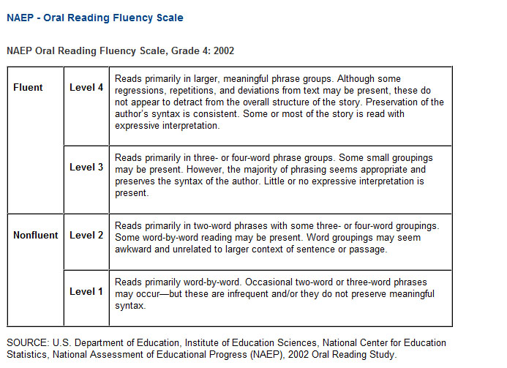
Table 3. Miscue Analysis based on the Oral Reading Fluency (Passage) Assessments
Based on the oral reading fluency assessment, report the text words and oral reading miscues on the oral reading passages in the table below.. Report your hypotheses and record the results of your miscue analyses in column 4. In column 5, record whether the miscue is visually similar to the original text word; in column 5 (50% of letters are same), record whether the miscue semantically preserves the meaning (makes same-sense in the sentence as original word, and preserves the passage meaning) in column 6; in column 7, record whether the miscue is syntactically similar (same syntax or part of speech). Add additional rows as needed. You can record SW for irregular sight words in the third column. For additional scaffolding and support in identifying the type of phonics errors committed by the student (see Text-miscue grapho-phonetic analysis column), consult a supplementary miscue analysis table organized by phonics patterns: View Download.

Record Passage Form or Grade Level | Text Word | Student’s Miscue | Text- Miscue Analysis  grapho-phonetic analysis [Consult Phonics table]: View | Vis Similar? Yes or No  (50% or more letters are same) | Semantically Similar  Yes or No | Syntactically Similar?  Yes or No
Fish F&P | - And | The | SW | No | No | No
Fish F&P | - A | The | SW | No | No | No
Fish F&P |  | In (addition) | SW | No | Yes | No
Fish F&P | - Or | Deletion | SW | No | No | No
Fish F&P |  | A (addition) | SW | No | No | No
Run Rec. Group Organism | - Grouped | Groups | Inflected Ending -s | Yes | Yes | yes
RRGO | - Ways | Way | Inflected Ending -s | Yes | Yes | Yes
RRGO | - You | The | SW | No | No | No
RRGO | - Classify | Classifying | Inflected Ending- ing | Yes | No | Yes
RRGO | - And | Than | SW | No | No | No
Secret Home F&P | - Hiking | Hike | Inflected Ending -ing | Yes | Yes | Yes
Secret Home F&P | - An | Deletion | SW | No | No | No
Secret Home F&P | - Winding | Wĭnding  (Mispronunciation) | Short vowel i | Yes | No | No
Secret Home F&P | - Obvious | Obvawz (mispronunciation) | Vowel diphthongs -iou | No | No | No
Secret Home | - Arachnophobia | Ar ch ni bia (mispronunciation) | Multisyllabic word | Yes | No | No
Plants | - Is | Its | SW | Yes | Yes | Yes
Plants | - Adaptations | Adaption (Mispronunciation) | Multisyllabic word | Yes | No | No
Plants | - sides | Side (Mispronunciation) | Inflected ending -s | Yes | No | No
Plants | - can | Could | Sw | No | No | No
Plants |  | And (Insertion) | Sw | No | No | No

The examiner’s copy for the oral reading fluency measures that I administered are in the attachments in D2L.

Table 4. Comprehension Retelling (Transfer these results to cover page in Table 1)
Student’s Initials | MK | Student Grade 5 |  | Examiner: Mathieson | Date: 9-27-16

  - Complete this table for each comprehension passage. Score 2 points for each story part produced in response to the direction: Retell the story. Tell me everything that you can remember. If item is only partly recalled, score 1 point. Score 0 points if no information is recalled.
Unassisted Retelling Category | Student’s Free Retelling: Record what student says in the relevant story categories | Points  2 pts.  (2, 1, 0) | Prompt Question (To Assess Comprehension)  [or … give these prompts if student doesn’t provide the fact in the unassisted retelling] | Story Questions or Prompted Retelling  Points (1 point)
- Setting: Where |  |  | - Where did the story take place? | 1
- When |  |  | - When did the story take place? | 1
- Characters: 1st | Leddy, Aunt | 2 | - Who are the character(s) in the story
- 2nd |  |  | - Anyone else? | - girl
 |  |  | - Describe _name of character_____ in the story. | 1
- Problem/  Challenge to MC |  |  | - What was the main character’s problem (or dilemma) in the story? | 1
- Goal/Motive (What does MC want to do |  |  | - What does ____ (main character) want to do about the problem? (goal?)  - How did _____ feel? (internal response) | N/A  1
- Events – Event 1  - Event 2  - Event 3 | The girls went to visit their aunt. Aunt checks off the list before hiking. “watch out for spiders”. They went on a hike. They learned about the trap-door spider. | 2 | - What happened in the story? Tell the story in your own words (2-3 points)  - What happened 1st?  - 2nd?  - 3rd?  - anything else?
- Solution |  |  | How was the problem/challenge solved? | 1
 | Total Parts Named Above 2 /10 = 20 % | total pts/20 = 4 | Total Parts Named Above 8 /10 = 80 % | total pts/10 =8
- (Optional) Theme |  |  | What was the author trying to tell us? | 1
 |  |  | What is the lesson or theme of the story? | 1

4.2 Column 2: Story Parts Recalled: Fill this out
- _20_ % of Story Parts in Free Recall = [ # of parts named above in column 2 2 /10 = 20% of total story parts recalled [make adjustments based on total possible parts]
- 20_ % of points in free recall = # of points in column 3 = 2/20 [increase points if there are more story events, or if you wish to evaluate theme]
% Points or Parts answered correctly given Story Questions or Prompted Retelling __80%__
Comprehension Placement Guidelines  Independent Level = 90% accuracy;  Instructional = 75%  Frustration = 50% | 4.3 The student is performing at Frustration (IND, INST, FRUST) level given the 5th grade reading passage. The student is performing at an instructional level when reading a 4th grade reading passage.  I feel that Comprehension is an area of concern because this student continues to need support and prompting in order to share what he learned or read in the book. Although this student scored an overall composite score of 8/10 or 9/10 in the F&P assessment, here it shows that only 20% of those answers were recalled freely by the student.
Additional information included in the F&P appendices.

Table 5. Sight Word Assessment and Results

You can use Table 5 for the San Diego Quick Assessment (placement based on graded sight word lists. The San Diego Quick Assessment is used to gather information about the students’ reading grade level. The purpose of graded word lists is to place a student in an appropriate reading grade level, and to decide where you might begin your administration of the graded passages for the Oral Reading Fluency assessment.

Assessment | Name of Instrument | Results (grade level, % accuracy, Indep, Inst, Frust, etc.)
- Norm-referenced Sight Word Assessment measure that was administered (San Diego, QRI-5, Read to Succeed, etc). Report grade level, % correct at that level. | San Diego Quick Assessment | Grade Level Admin.  PP  1:  2:  3: 90%  4: 90%  5: 90%  6: 60% | Indep, Inst, Frust??  Independent  Independent  Independent  Frustration
- Follow-up Sight word assessment that was administered (Fry List, Dolch list,) Report % accuracy at specific levels/sublists (e.g., PP, P, 1, 2, 3, etc.; 1st 100; 2nd 100; 3rd 100) | Name of Assessment  _Fry List 1000_ | PP: 1st 100  Dolch List Fry List % accuracy  PP K-1: 1st 100 98%  P  1:  2 G2-3: 2nd 100  3 G2-3: 3rd 100 97%  4 G4-5: 4th 100  5 G4-5th: 5th 100 95%  5 G4-5th: 7th 100 94%

Table 6. List miscues on the Sight Word Inventories and your specific analysis of the miscues.
A second purpose for a sight word assessment is to identify and develop a pool of high-frequency words that should be taught. Although many sight words are irregular words, record any information about decodable regular parts in the Analysis column that will you to confirm your decisions about what or how to teach. Realize that, if a word is irregular and cannot be sounded out (e.g., want, come), simply record SW in the analysis column. However, if the word has predictable or decodable word patterns, you need to analyze the miscue & record the omitted information in the last column. For additional scaffolding and support in identifying the type of phonics error in the miscues, you may consult a supplementary miscue analysis table organized by phonics patterns: View Download

Sight Word | Student’s Error/Miscue | Analysis or word patterns (other words that might be taught) – see 220 words are too many for kids like mine
EXAMPLE1: back | bake | -short a, -ack pattern (e.g., black, tack, sack, jack, lack, rack)
EXAMPLE2: come | Cuh | Irreg. SW
- Exclaimed | Exclamation | Inflected ending -tion
- Silent | Sihlent | Long vowel I
- Acquainted | Occupied | Focus on each syllable in the word, initial consonant -o
- Abolish | Apolish | Focus on consonant sounds orthographic practice -p
- Apparatus | Apair ih tus | Short vowel sounds -a
- Necessity | Decessity | Initial consonant -n
- Relativity | Realitivity | Focus on each syllable in the word
- As | Has | SW
- Than | Then | Short vowel, SW
- Thought | Though | Irregular Sw, inflectional ending -t
- Next | Like | SW
- Father | Fether | Short vowel -e
- Box | Both | CVCC Blends -th
- Known | Now | Irregular SW, CCVC blends -kn
- Heat | Heart | R controlled vowel -ar
- Noun | None | Irregular SW, diphthong –ou, CVCe
- Material | Matteral | Long E vowel, diphthong
- Century | Central | R controlled vowel -ar
- Laughed | Laugh | Inflected ending -ed
- Consonant | Consonate | Short vowel a, inflected ending - t
- Per | Peer | Vowel teams , long e vowel -ee
- Melody | Meldy | Long o vowel
- Iron | Irn | Irregular SW

Add lines as needed. Include sight word assessments.
Table 7. Phonics Assessment and Results: CORE PHONICS SURVEY
The table below is provided to help you to summarize and to report the results of your phonics assessment. You can use this table, or you can devise your own table for reporting the results. For older students, you might wish to add or replace with the Walpole and McKenna Informal Decoding Inventory to focus on multi-syllabic word reading. Table 7 below is designed for the CORE Phonics Survey, but the instructor can help you make modifications to this table if you administer another assessment. Record the % accuracy on each subtest in Column 2, and consult the standards on the cover sheet of the Core Phonics Survey to identify riskness. Record the letters/words missed in the third column; write the substitution or error in the 4th column; and record your analysis of the error in the last column.
Benchmark: 14/15 words
Strategic 10-13/15 words
Intensive: 0-9/15 words
Table 7. Phonological Awareness or Phonics Assessment and Results: Core Phonics Survey
Assessment | Results (% accuracy, fluency, grade level, number of words missed, etc.) | Analysis or Miscue Analysis (examples and evidence). Begin to dentify which elements are difficult. |  | In this column, analyze and name the missed elements
- Part C Letter Sounds |  | Letter | Sound
- Part D CVC Words with Short vowel Sounds | Reads CVC Words  ___/15 words =  ___% accuracy  Riskness: | Text Word | Miscue
- Part E  Short Vowels with ditraphs –tch, trigraphs | Reads CVC Words with digraphs and short vowels  12/15 words =  80% accuracy  Riskness: Strategic | Sip  Mat  Not | Slep  Bat  Nope | Incorrect vowel sound -e, adding a CCVC consonant blend -sl  Initial consonant sound -b  Adding the e creating a new word- CVCe
- Part F  Cons. Blends with Short Vowels | Reads words with short vowels & Cons. Blends  13/15 words =  86% accuracy  Riskness: Strategic | Quit  Qued | Quiet, quite  Quad | Reading visually similar words, vowel digraph –ie, ui  Short vowel sounds and digraphs -ua
- Part G  Short Vowels with digraphs and tch Trigraph | Reads Words-Short Vowels with Digraphs & Trigraphs 14/15 words =  93% accuracy  Riskness: Benchmark | Chop | Drop | Incorrect first consonant sound -d
- Part H  r-controlled vowels | Reads words with r-controlled vowels  13/15 words =  86% accuracy  Riskness: Strategic | Bark  Gorf | Park  forg | Initial consonant sound -p  Mixing up location of letters
- Part I. long vowel spellings (CVCe, CVVC, CVV) | Reads long vowel words (CVCe, CVVC, CVV)  14/15 words =  93% accuracy  Riskness: Benchmark | Hine | Hin | CVCe
- Part J. variant vowels (Vowel Dipthongs) | Reads words with variant vowels (dipthongs)  13/15 words  86 % accuracy  Riskness: Strategic | Toy  zoy | Toe  Zo | Vowel sounds, diphthongs -oe  Vowel sounds, diphthongs -oy
- Part K  low frequency vowel and consonant spellings (silent letters) | Reads low frequency vowel and consonant spellings  14/15 words =  93% accuracy  Riskness: Benchmark | Sweat | Sweet | Vowel teams -ee, similarly spelled word
- Part L  Multisyllabic words:  VC/CV (closed/___)  V/CV (open/____)  _le (consonant_le) | Reads multisyllabic words with correct 19/24 words =  79% accuracy  (24 words) | Competes  Rompete  Radishes  Railways | Kompehts  Rompeht  Radish  railway | Long e vowel sound  Long e vowel sound  Inflected ending -s  Inflected ending -s

Table 8. Spelling Assessment and Results (Words Their Way Assessment): Students in Section 734 [NOT TO BE ADMINISTERED]
The table below is provided to help you to summarize and report the results of your Words Their Way spelling assessment. You will include the spelling assessment in the Appendix. Record your scores in the column or row associated with the spelling level administered (e.g., Primary, Elementary, Upper Level)
Assessment | Spelling Level | # Correct | Overall Percent | Feature Points/% | Spelling Stage
Norm-referenced Spelling Assessment  Words Their Way | Level Administered:  Primary  X Elementary  Upper Level | Primary: ____ /26 |  | ___ / 56
 |  | Elementary: 13_/25 | 55/87 = 63% | 42/62
 |  | Upper: _____ / 31 |  | ____ 68

Table of Conversion: Percent accuracy: 7-items: 6/7 = 86% 5/7=71% 4/7=57% 3/7=75% 2/7 = 29% 1/7=14%
6-items: 5/6= 83% 4/6=67% 3/6=50% 2/6=33% 1/6= 17%
5-items: 4/5=80% 3/5=60% 2/5=40% 1/5=20%

Summarize Performance: on subskills: Record Performance in Proper Column below, and calculate % accuracy on each skill (See conversion table above for %). Highlight cells for which there are problematic areas. Record specific notes about vowels or sounds missed.
Primary Spelling Inventory: Summarize results here |  |  | Elementary Spelling Inventory: Summarize Results Here |  |  | Upper-Level Spelling Record Results
Subskill (total possible) | Subskill % Accuracy | EX: missed Sound Orthog. Elements | Subskill (total possible) | Subskill % Accuracy | EX: List Missed Sound Elements | Subskill (total possible) | Subskill % Accuracy | Ex: Missed Sound /Orthog Elements
Consonants: (7) |  |  | Consonants: ( 7) | 100% |  | Blends & digraphs (5)
Short vowels: (7) |  |  | Short vowels: (5) | 100% |  | vowels: (9)
Digraphs (7) |  |  | Digraphs (6) | 100% |  | Complex Cons. (7)
Blends (7) |  |  | Blends (7) | 100% |  | Inflected Endings (8)
Long Vowels (7) |  |  | Common Long Vowels (5) | 80% | igh | Unaccented Final Syll. (7)
Other Vowels (7) |  |  | Other Vowels (7) | 86% | er | Affixes (4)
Inflected Endings (7) |  |  | Inflected Endings (5) | 80% | pping | V in unaccented syll (2)
 |  |  | Syllable Junctures (5) | 100% |  | Greek & Latin Elem (4)
 |  |  | Unaccented Final Syll. (5) | 40% | le, or, ar
 |  |  | Harder Suffixes (5) | 20% | ure, ate, ize, ion
 |  |  | Bases or Roots (5) | 20% | pleas, fortun, civil, pos

Table 9. Summary of Strengths
Based on the Assessments that you administered, Summarize the student’s Strengths and Weaknesses. These should be the relative strengths of the student (e.g., What the child can do at instructional or mastery levels). Once recorded here, you can transfer the relevant strengths and weaknesses to the Intervention Plan (Projects 3, 4, and 5).

Strengths: What the student knows and/or can do, and if relevant, at what level
Example: Student can read second grade passage at a fluency level of 98 wcpm, which is at the XXth percentile level for the Winter administration.
- MK can read fifth grade passages with 97% accuracy or higher.
- MK can self-correct his reading and recognize when a passage does not make sense after omitting words (both F&P assessment and fluency assessment).
- MK is able to read high frequency words with 90% accuracy at a 5th grade level.
- MK has an phonological awareness when hearing words with short vowel sounds, scoring 100% accuracy on his WTW assessment in regards to short vowel features.
- When reading a MAZE passage, MK was is able to select words that fit syntactically with 100% accuracy.
- MK can read approximately 86 words per minute when reading 4th grade leveled text.

Table 10. Weaknesses: What the student needs assistance with, or what skills does the student perform below expected grade levels or mastery levels.

Weakness: What the student does not know and/or cannot do proficiently, and if relevant, at what level
Example: Student decoded prefixed or affixed words (e.g., re- dis- un-) with only 50% accuracy
- MK inaccurately reads vowel sounds in high-frequency words and nonsense words, he is in the strategic risk category, however, this is something he could still use assistance with since he is approaching 6th grade soon.
- MK is not fluent when reading at his instructional level, especially in regards to prosody and pausing for punctuation. Student can read 4th and 5th grade passages at an average fluency level of 86 wcpm, which is around the 29th percentile for the Fall administration.
- MK has difficulty with suffixes and roots of upper elementary words, scoring only 20% when looking at the words features.
- MK was able to freely recall 20% of a grade level text without prompting.
- MK has difficulty reading at a fluent 5th grade benchmark level, averaging 77% accuracy with comprehension questions.

Table 11. Write Goals/What Student will be able to do at end of year or semester
Use this format: Given [list condition/instruction/materials] …… Student will be able to do …… [what observable behavior] … what criterion levels [what criterion levels indicate acceptable performance]. Add rows as needed (hit tab in table). Think about writing goals for phonics, sight words, oral reading fluency, comprehension.
Goals [Write like objectives] Deadline/Date
- In his classroom setting, MK will be able to read a 5th grade text, leveled S (instructional level) with 91% accuracy. | December 2016
- When reading an instructional book, MK will be able to freely recall information and evidence from the text with 75% accuracy. | May 2016
- When reading sight words, MK will be able to recall or decode multisyllabic words with 93% accuracy (benchmark). | June 2016

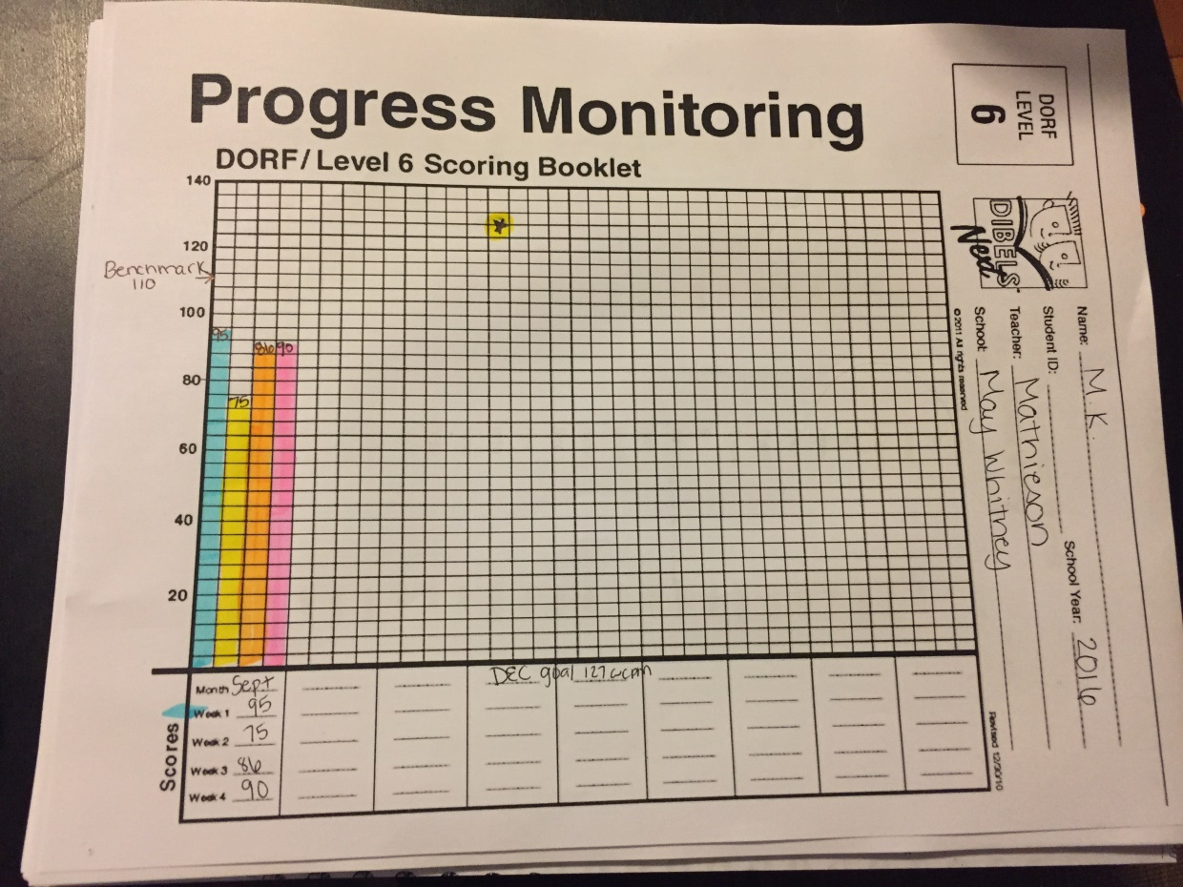

Rubric for Project 2: Reading Assessment Include copies of all assessments.
Name: | Your total Points: | 50 points possible

Component of the Assessment Portion of the Assignment |  | Your Points | Total Possible Points
 | Record miscues on the examiner’s copy accurately (include ORF passages). |  | 2
 | Report the student’s oral reading accuracy on the oral reading fluency passages. Accurately use norms to establish independent, instructional and frustration levels. (see Table 1; part 1.2 at bottom) |  | 4
 | Accurately report the student’s oral reading fluency on the oral reading fluency passages, and use Fluency norms (dibels, AIMSweb, Hasbrouck-Tindal) to establish fluency levels. Provide evidence that supports your conclusions regarding student’s fluency. (e.g., Hasbrouck & Tindal) (see part 1.3 of Table 1) |  | 5
 | Set appropriate accuracy/fluency/comprehension goal according to a reasonable timeline (see part I.4). |  | 5
 | Use NAEP criteria and prosody features to evaluate the qualitative dimensions of a student’s oral reading fluency (see Table 2). |  | 3
 | ²Analyze oral reading miscues by performing error analysis (miscue analysis); Analyzes visual, syntactic and semantic properties of the miscues (Table 3) |  | 5
 | Administers comprehension assessment and interprets the diagnostic information appropriately using Table 4 (4.1, 4.2, and 4.3) |  | 4
 | Administer and report Slosson Oral Reading Test (Table 5) & accurately conducts and reports miscue analysis (Table 6) |  | 5
 | Develop and/or administer probe of phonics skills (e.g., word analysis skills, etc.) and Words Their Way (Section 734) assessment Report Phonics assessment results and summarize miscues analyses in a manner that is accurate, relevant and appropriate (see Tables 7 & 8) |  | 4
 | Summarize the Student’s Strengths and Weaknesses Accurately and Thoroughly (Tables 9-10) |  | 5
 | Collect a minimum of 3 days of baseline using additional fluency probe to collect further information on targeted area(s) of concern (e.g., 1 minute probe of phonics skills, ORF, etc). Plot data on fluency chart (Figure 12) |  | 3
12. | Write Goals Statement (like objectives) (Table 11) |  | 5
 | Total Points |  | 50

Preserves the intended meaning of the original text word, e.g., substitutes the word ‘puppy’ for ‘dog’ .
Maintains the syntactic class of the text word, e.g., substitutes a verb for a verb, e.g., substitutes the word “walked” for “ran” in the sentence: He ran to the store (child says: “He walked to the store”. This preserves the syntactic features of the original text word, but it is semantically different.

